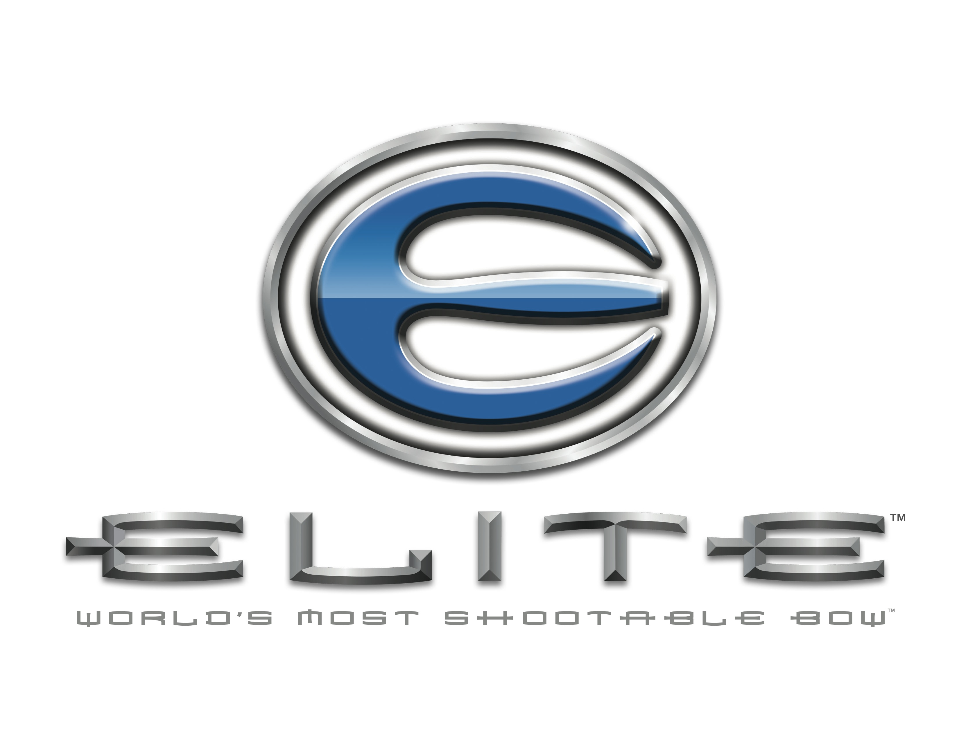
Contact Information: 877-503-5483
235 Middle Road Henrietta NY 14467

FOR IMMEDIATE RELEASE

World Champion Archer to Shoot Elite Archery Bows
Levi Morgan Made the Switch

Henrietta NY, November 1 2013: Elite Archery has signed a multi year contract with World Champion Archer and bowhunter, Levi Morgan. Effective November 1, 2013, Levi will shoot Elite Archery bows exclusively in competition and also on his television show Name the Game™ with Levi Morgan.

“I love this sport. I love archery, I love the competition and I love bowhunting,” said Levi. “I love the whole idea behind the archery lifestyle and it has been my life. To work with a company that feels the same way and wants to grow and wants to be better is exactly what Elite Archery has offered me.”

“We’ve always known that we have a shootable bow,” explains Elite Archery President, Pete Crawford. “We talk about Shootability. We talk about the draw cycle and how the way our bows hold against the solid stops is really important to hunting. And what we’ve found is that Shootability also equals accuracy. Not just when you are shooting paper or foam, but also in the woods. We’ve got a team of people that bowhunt as passionately as they shoot target archery. And to be honest, professional archers like Levi spend more time thinking about how a bow works, how it could be better, than we ever have a chance to do. That resource is invaluable on so many levels.”

Levi Morgan is a seven time ASA Shooter of the year, has won more than 40 National Champions and holds 10 World Championship titles. In July, 2012 he debuted his bowhunting television show, Name the Game™ with Levi Morgan on The Sportsman Channel to excited viewers who were ready to see another side of arguably one of the best archers ever to step up to the competition line.

“I’ve never been this motivated,” commented Levi. “I’ve never been this excited about going out with my new Elite on tour and posting some scores because this bow shoots unreal. I’ve never held anything in my hands that I was so confident in, in such a short period of time.”

“Levi Morgan isn’t only one of the best competitive archers on the circuit today; he is also an accomplished bowhunter and a great ambassador for the Shootability message we’ve been telling our customers about for more than a year,” said Elite Archery Vice President, Garret Armstrong. “Levi helps us to bridge the gap between the Target Archery and Bowhunting communities because he understands how Shootability will not only help him in the field but also in competition. It speaks volumes about our products that the country’s top archers are making the switch to Elite.”

“Do what I did and try one,” Levi went on to say. “Just go shoot one and until you do that, you won’t understand it.”

In addition to shooting Elite Archery bows, Levi will continue to use other equipment from The Outdoor Group brands including Scott Releases, Custom Bow Equipment, Duel Game Calls and Winner’s Choice Custom Bow Strings.

ABOUT ELITE ARCHERY
Established in 2006, Elite Archery is a high-end compound bow company based in Henrietta, New York. Elite’s line of compound bows consist of two track binary cams with the efficiency that’s to be expected from a high-energy cam system, but with the smoothest draw cycle available. For more information, visit www.elitearchery.com, like us on Facebook at www.facebook.com/EliteArchery or follow us on twitter at www.twitter.com/Elite_Archery

ABOUT THE OUTDOOR GROUP
Established in 2012 and based in Henrietta, New York, The Outdoor Group is parent company to the premier brands of Elite Archery, Perfect Form Manufacturing, Duel Game Calls, Scott Archery, Custom Bow Equipment, Winner’s Choice Custom Bowstrings and Solid Broadheads.

Media questions can be directed to Maggie Armstrong at maggie@togllc.com

